Assignment 3 Summary
Assumptions
- User wants to append data to output file
- User will sort and show data before writing to file

Main Outline
Program Flow:
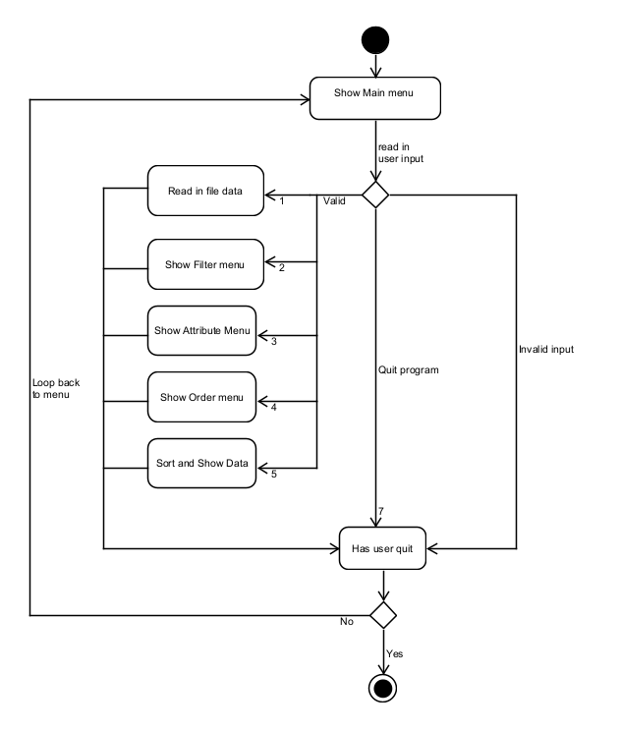
ReadFile() function
Program Outline
- Loop through each line and place them in a string
- Check the name of the shape and extract the values to create the object
- Insert the object into a set to ensure uniqueness
- Loop through the set and insert the list of objects into a vector

ExtractPointValues() function
Program Outline:
- Find the positions of ‘[‘ and ‘]’
- Create a substring and remove all whitespaces
- Pass the substring into a stream and use getline with ‘,’ as a delimiter to tokenize the string
- Place each value into a vector and return the vector

Comparator functions (function template)
- Create comparator function templates for:
- Compare X and Y value functions
- compare Points functions
- compare Scalar Values functions

CompareXYValues()
Program Outline:
- If X values are the same, Sort according to Y values
- Else, sort according to X values

Display functions (function template)
Program Outline:
- Loop through the vector and place them in a string stream
- Return a string

Store Data function
Program Outline:
- Initialise the ofstream object
- Call display functions which return string and insert them into the stream
- Close file

Lessons Learned
I learnt how to use function templates to do compile-time polymorphism and also learnt to use STL containers for specified usage like sets to get uniqueness and functions to simplify operations like sorting. I think I could have improved better by using class templates instead of repeating many due functions due to different implementations of classes.

